# **Introduction**

Estuaries around the world are under cumulative stress from a variety of natural and anthropogenic disturbances, which may occur over short or sustained periods of time and contribute to reduced ecosystem resistance to new disturbance (Diefenderfer et al., 2021; Megonigal & Neubauer, 2019; Pasternack, 2009). Sources of cumulative stressors may come from ecosystem scales, such as extensive conversion of estuarine floodplain to municipal and industrial use (Finn et al., 2021), or local disturbances such as scouring events during storms or tidal surges (CITE).These cumulative impacts can have consequences on plant communities comprising estuarine habitat, such as biodiversity loss, species homogenization, or increased non-native invasive species (Price et al., 2020). In turn, this can lead to ecological “memory loss” as historically abundant species become extirpated, or nutrient and successional processes change in response to disturbance pressures (Johnstone et al., 2016; Schaefer, 2011).

Disturbance in estuaries is not inherently negative and may have positive impacts on plant communities. Grazing is one example of natural disturbance which may positively or negatively affect plant community diversity and abundance depending on grazing intensity (Lodge & Tyler, 2020), or shift abundance of community-dominant species (Choi et al., 2022; Gonzales & Arcese, 2008). In cases where grazing disturbance is removed, plant communities may be expected to passively recover through natural recruitment and succession (CITE). However, intensive or persistent grazing can effectively reset successional processes through total removal of propagative materials, and potentially set the plant community on a recovery trajectory towards an alternative stable state (CITE). Understanding plant community recovery in grazed estuaries is an important knowledge gap which requires understanding potential species introductions from surface-level seed banks and above-ground vegetation composition.

Recruitment of dominant plant species in estuary habitat is largely driven by environmental constraints such as salinity, and plant interactions like competition and facilitation (Bertness, 1991; Bruno, 2000). Furthermore, recruitment of plants following a disturbance like grazing is dependent upon remaining propagules such as clonally reproductive fragments or seeds. In estuaries, these propagules are dependent upon sufficient stress-free “windows of opportunity” to establish, where clonal fragments have a greater stress tolerance to recurring tidal disturbance than seeds (Silinski et al., 2016). Availability of historically dominant species’ propagules and their respective competitive advantages is species-specific, and competitive growth strategies of historically dominant species may be overshadowed by propagule pressure following disturbance (Lavorel & Lebreton, 1992).

Estuaries around the Salish Sea in the Pacific Northwest of North America are dominated by swards of graminoids (sedges, rushes, grasses) whose competitive strategies include clonal reproduction and tall (> 1 m) canopy cover, interspersed with a diversity of broadleaf, flowering species (“forbs”) (Borde et al., 2020). Many estuaries in this region are overgrazed by non-native, hyperabundant Canada geese (*Branta canadensis*) (Dawe et al., 2011; Dawe & Stewart, 2010). In addition to removing leafy above-ground vegetation, Canada geese will rip out or “grub” starchy rhizomes capable of clonal reproduction, which in turn increases potential for ecological memory loss in the form of eroding marsh sediments and their seed banks. Estuary plant communities impacted by intensive goose herbivory must either recover from clonal expansion from adjacent remnant patches, or through seed recruitment from seed dispersed and retained on the eroded site. Whether plant communities passively recover towards a compositional abundance similar to ungrazed plant communities is an understudied topic in this region, particularly with respect to recovery of seed banks at the marsh surface. Our main objective of this study was to understand compositional changes of surface seed banks and above-ground vegetation at discrete stages of recovery since grazing in two Salish Sea estuaries. Traditional succession models would say the most competitive species will increasingly dominate the plant community as time since disturbance increases. This would particularly be the case in a clonal ecosystem, where recovery is driven by species spreading clonally from adjacent undisturbed sites, in addition to potential recruitment from the seed bank. If succession is happening the way we expect:

1. Compositional abundance of dominant tall, perennial graminoids in above ground vegetation at older disturbance sites will have greater similarity to undisturbed (reference) vegetation than recently disturbed sites.
   1. Alternatively, novel disturbance can lead to alternative succession pathways, where new species can achieve competitive dominance through seed or clonal recruitment, derailing the slow clonal encroachment of historically dominant species from neighboring sites. If this is the case, we expect compositional abundance of competitively dominant species in the older disturbance sites will be significantly different from that of undisturbed sites.
2. Because a longer post-grazing recovery period should facilitate greater seed bank richness, we expect compositional abundance of surface seed banks should closely resemble that of above-ground vegetation in recently disturbed sites, and become more species-rich and dissimilar from above-ground vegetation with time since disturbance.

# **Methods**

## **Study area & site history**

The Little Qualicum River Estuary (LQRE) and Nanaimo River Estuary (NRE) are situated on the east coast of Vancouver Island along the Strait of Georgia (Figure 1) and are on the ancestral, unceded territories of Coast Salish Peoples, including the K’ómoks, Snuneymuxw, Qualicum Band, and Nanoose First Nations. Prior to European colonial settlement, traditional practices by First Nations around the Salish Sea would have included managing estuaries as root gardens to promote the abundance of broadleaf flowering species with starchy roots, rather than the perennial graminoids that competitively dominate the estuaries today (Turner et al., 2013). Colonial settlement of the LQRE began in 1887, with cattle grazing, log booming, and sawmill operations being the chief uses of the estuary until 1974 when 29 ha of the estuary were donated to the Canadian Wildlife Service for conservation purposes, and subsequently designated as a provincially protected Wildlife Management Area (WMA) in 1993 (CITE). The NRE was similarly settled through the late 19th and 20th centuries, and heavily augmented through construction of a ferry terminal, logging operations, and coal mining. While the NRE is part of the UNESCO-designated Mount Arrowsmith Biosphere Region and portions fall under conservation management, it is not provincially protected through designation as a WMA.

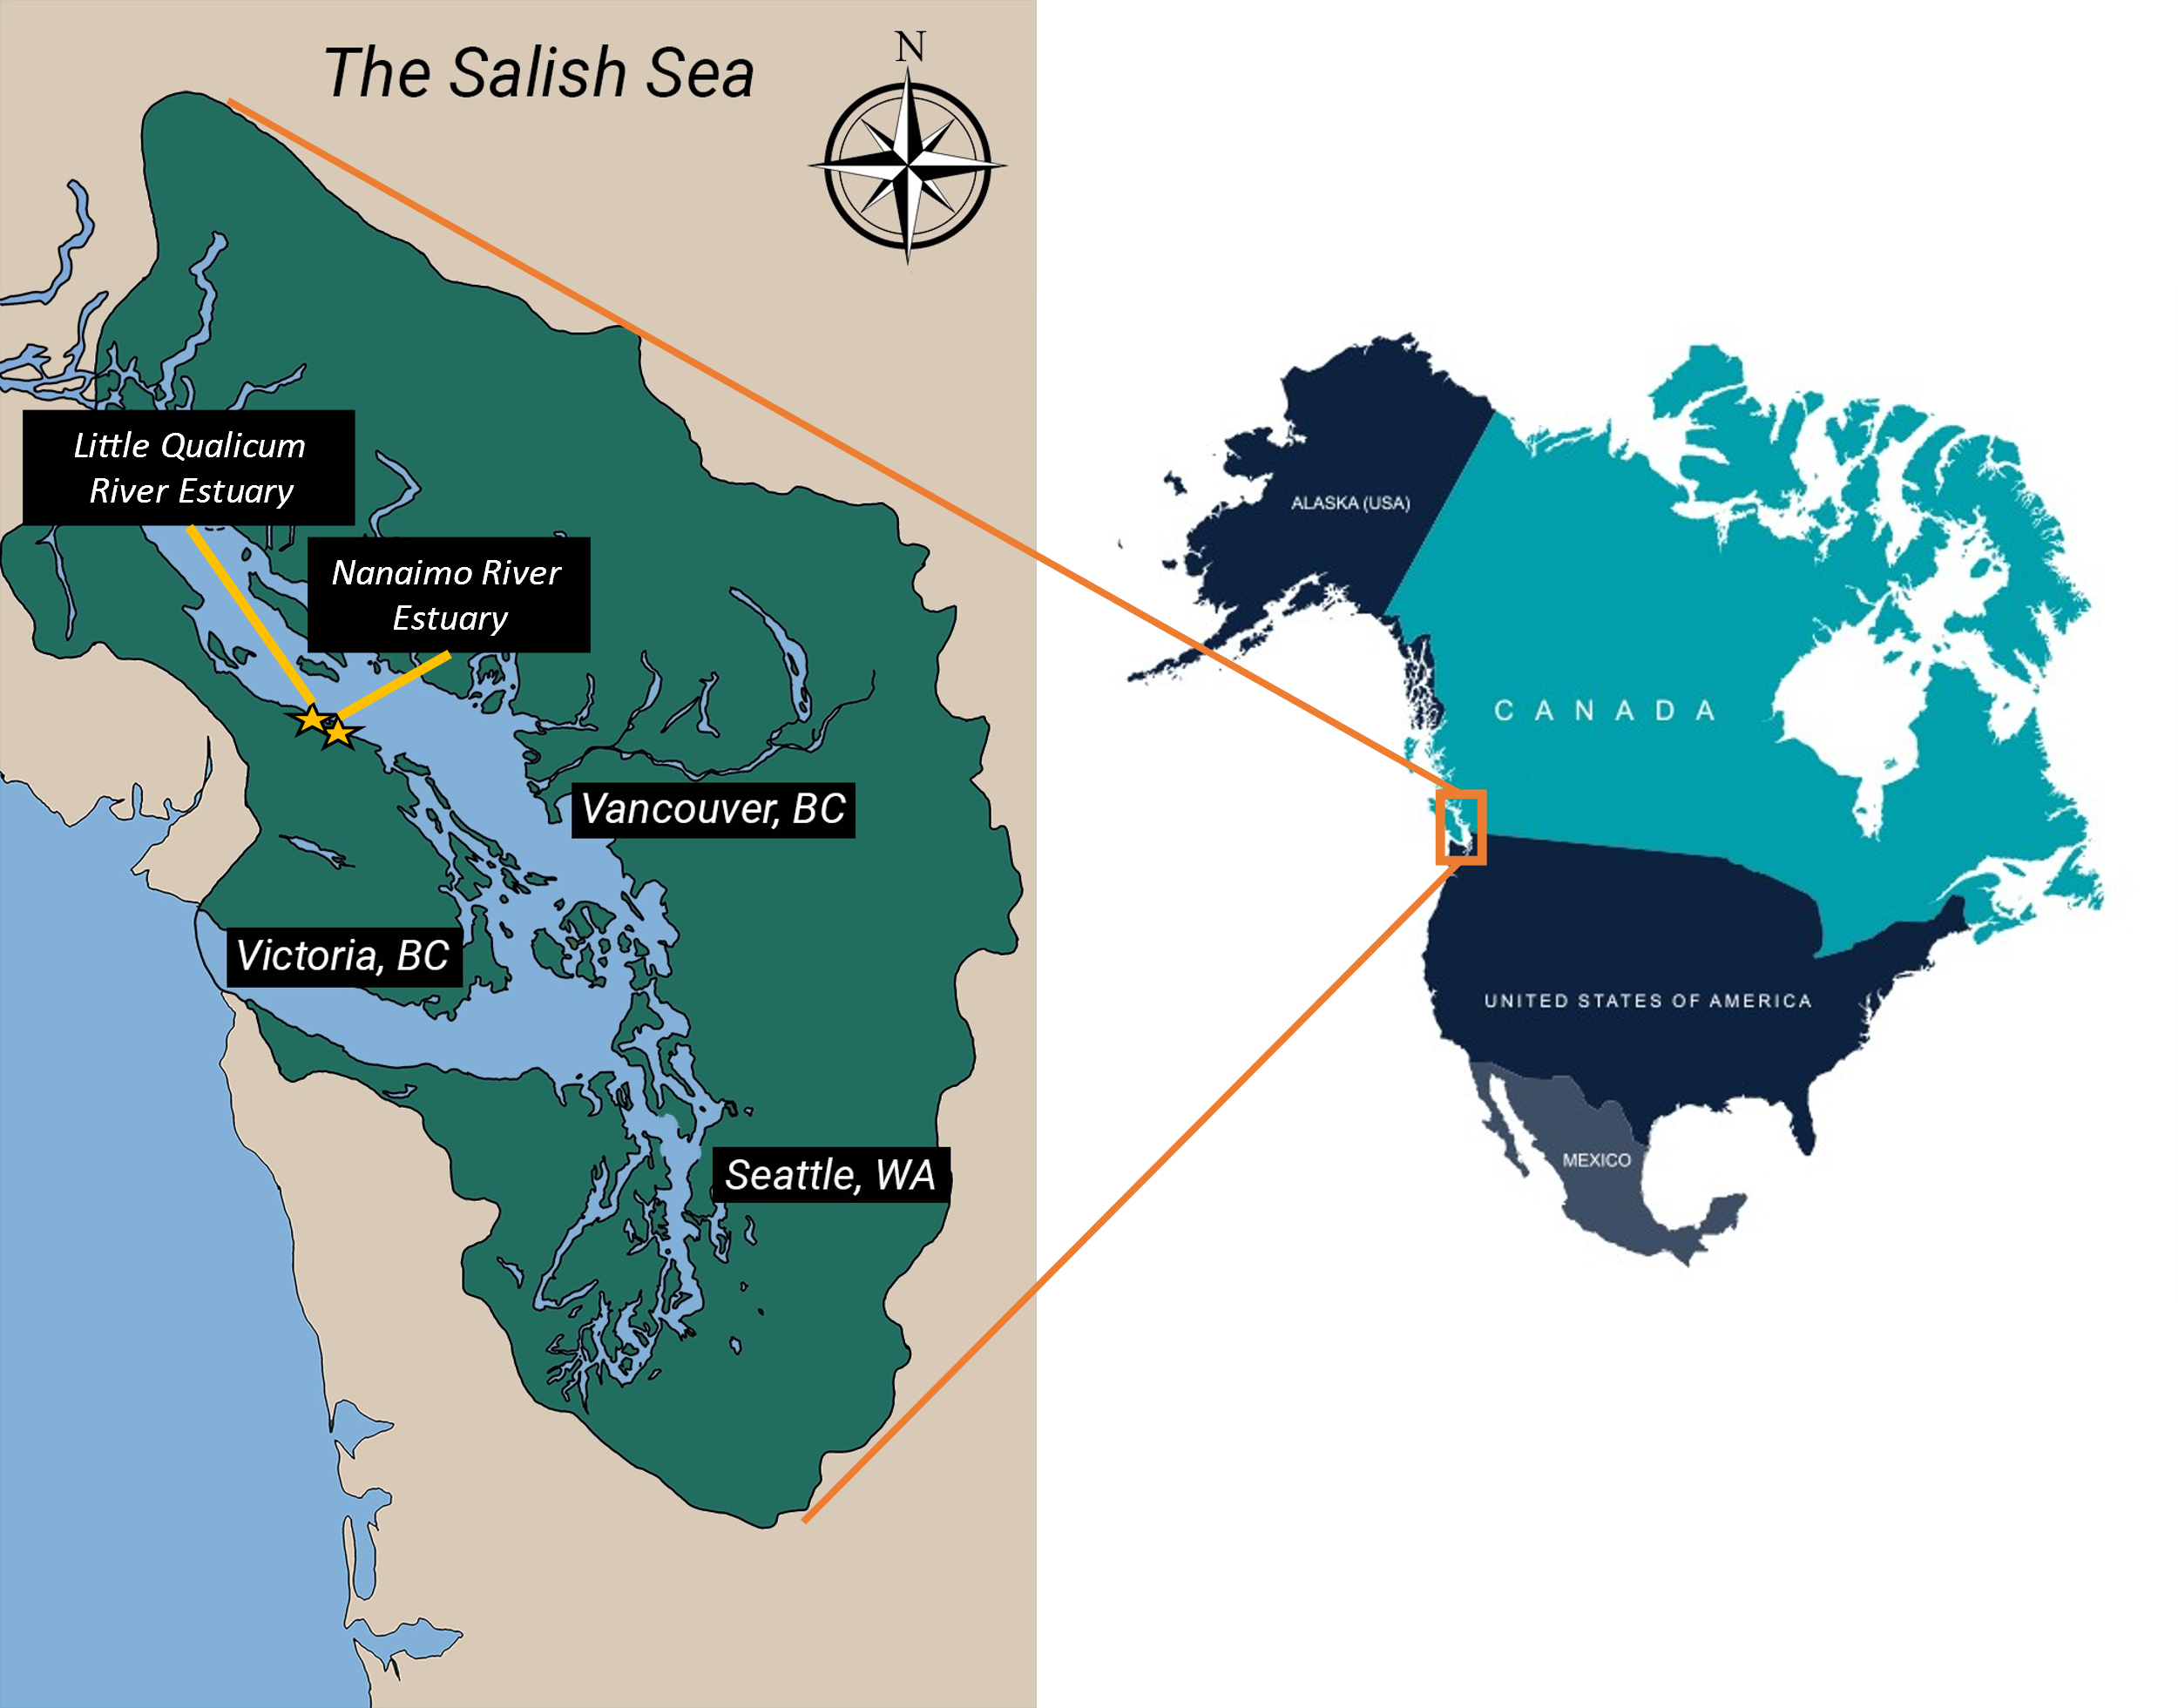

Figure 1. PLACEHOLDER MAP: The Salish Sea spans the US-Canadian border on the Pacific Coast of North America (inset). The Little Qualicum River Estuary and Nanaimo River Estuary are within approx. 40 km of each other along the southeast coast of Vancouver Island. Salish Sea map from IntoTheSalishSea.org, reproduction for publication not permitted.

## **Goose introduction & grazing exclusion**

Canada geese (*Branta canadensis*) were historically a migratory species to Vancouver Island, however in the late 20th century populations were introduced to the island promote hunting tourism. In the absence of sufficient hunting pressure these populations have grown hyperabundant, and have become resident within the region rather than becoming migratory like their wild counterparts. (Dawe & Stewart, 2010) These hyperabundant populations place heavy pressure on estuaries through sustained herbivory, leading to complete loss of above- and below-ground plant structures, leading to denuded marsh platforms which result in sediment and seed bank loss through erosion.

Fences or “exclosures” are an effective strategy to exclude herbivores, including Canada geese, from continued grazing (CITE). A history of exclosure construction since 2010 in the LQRE, and recent history of exclosure construction in NRE since 2020 afford the opportunity to develop a broad chronosequence of recovery at discrete time periods since grazing disturbance, including Grubbed (denuded mudflat), 1-year old exclosures, 10-year old exclosures, with comparison to areas that have no known history of grazing (Ungrazed or “reference”). Exclosures are constructed along the edges of vegetation impacted by grazing activity, with the rationale that remnant vegetation should recover towards a desired Undisturbed or “reference” condition once grazing pressure is relieved.

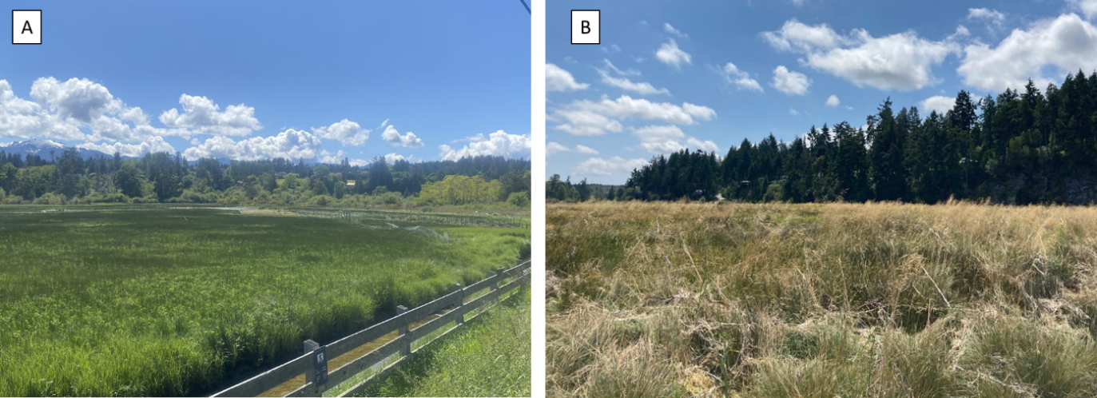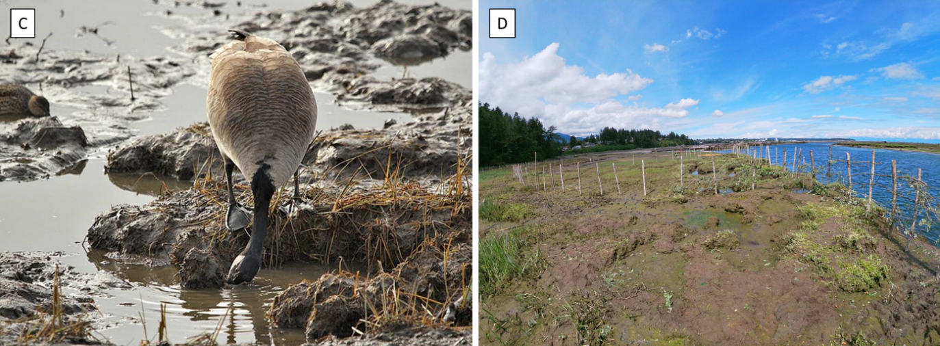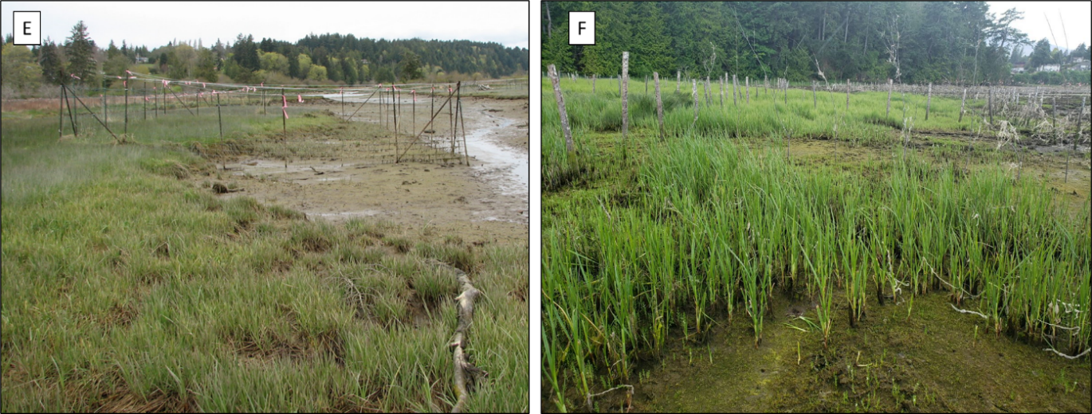

Figure 2. Reference vegetation for this study was defined as areas with no known grazing disturbance and dominated by native species, including Carex lyngbyei in in the Little Qualicum River Estuary (A), and Juncus balticus or Deschampsia caespitosa in the Nanaimo River Estuary (B). Intensive grubbing (C) by Canada geese (Branta canadensis) removes rhizomes and contributes to sediment loss, resulting in large areas of bare or “denuded” mudflat (D). Exclosures were constructed around the edges of these grazed areas to promote vegetation recovery in 2010 in the Little Qualicum River Estuary (E) and Nanaimo River Estuary in 2020 (F). Photo credits (A) Dawson Clermont, 2021, (B) Stefanie Lane, 2021, (C) Gerry Fairbrother, date unknown, (D) Garreth Ashley, 2021, (E) Neil Dawe, 2011, (F) Tim Clermont, 2020

Table 1. Grazing disturbance conditions in the Little Qualicum River and Nanaimo Estuaries resulted in conversion of vegetated marsh to partially or fully grubbed mudflats; exclosures were installed to prevent further degradation into the marsh platform. Each estuary sampled n = 4 sites for disturbance category. Two 1 m2 plots were sampled within each site, and two surface seed banks samples were taken from each plot.

|  |  |  |  |  |  |  |  |
| --- | --- | --- | --- | --- | --- | --- | --- |
| **Estuary** | **Time Since Disturbance** | **Disturbance condition** | **Revegetation status** | **Protected by exclosure?** | **Number of sites (exclosures, or comparably sized area)** | **Number of sampling plots per site** | **Number of surface seed bank samples per plot** |
| Little Qualicum, Nanaimo | 0 years (recent grubbing disturbance) | Grubbed | No manipulations | No | 8 | 2 | 2 |
| Nanaimo | 1-year post-grazing/grubbing disturbance | Partially grubbed | No transplants; vegetation recovery from remnant and adjacent vegetation | Yes | 4 | 2 | 2 |
| Little Qualicum | 10 years post-grazing/grubbing disturbance | Partially grubbed | No transplants; vegetation recovery from remnant and adjacent vegetation | Yes | 4 | 2 | 2 |
| Little Qualicum, Nanaimo | No known grazing disturbance | Undisturbed | No manipulations | No | 8 | 2 | 2 |

## **Sampling methods**

### **Vegetation sampling**

Vegetation sampling was conducted once in mid-July, 2021. Two 1 m2 vegetation plots were placed within the exclosures (sites, n = 4 per estuary), at least 1 m from the bank edge and any exclosure boundary, and at least 3 m apart within the exclosure. Quadrats were placed so that the plot edge nearest creek was parallel to the bank.

All vascular species were identified according Hitchcock and Cronquist (2018). Species were considered in the plot if at least half of their basal stem(s) were inside the quadrat boundary; overhanging vegetation originating from basal stems outside the plot was not considered. Aerial vegetated cover was estimated to the nearest 3 % (1/32 m2). For any species present with less than 3 % cover, species were assigned 2% cover if > 20 individuals were present, 1 % cover if 2-20 individuals were present, and 0.1% cover for single individuals. Bare ground was estimated as the remainder of the plot area not covered by above-ground vegetation. Any plots with > 100% cover were standardized relative to 100%. To characterize plant structure, all species were assigned to a height category tall (> 1 m), medium (50-100 cm), or short (< 50 cm) based on their maximum reported height in the Illustrated Flora of British Columbia (Douglas et al., 1998). Our key species of interest, tall perennial graminoids (TPGs) were defined as any grass (Poaceae), sedge (Cyperaceae), or rush (Juncaceae) with a biennial or perennial life history and mature height of at least 1 m.

### **Surface seed bank sampling & germination**

Two surface seed bank samples were taken from each plot (n = 16 per disturbance condition in each estuary) in summer (July 2020), fall (October 2020), and spring (March 2021). A 10 cm diameter handheld bulb planter (e.g., [Husky 9 in. stainless Steel Bulb Planter, Home Depot, USA](https://www.homedepot.com/p/Husky-9-in-Stainless-Steel-Bulb-Planter-GD210314/317436441)) was used to excise sediment 1 cm deep to capture the most recent seeds deposited into the marsh sediment, which we call the “surface seed bank.” Vegetative roots, rhizomes, or other viable rooted material were removed before placing sample in a plastic zipper bag. All surface seed bank samples from the same estuary and disturbance condition were then homogenized in a clean bucket with 100 mL dechlorinated water. Samples were hand-sifted for any remaining root, rhizome, or vegetative material, then homogenized sample was transferred to a clean plastic zipper bag. Summer and fall 2020 samples were stored at 4o C for approx. 12 weeks to simulate overwinter cold stratification to release seed dormancy (CITE); samples collected in the spring of 2021 underwent natural winter conditions within the estuaries and were not subjected to cold stratification.

Germination trials were conducted under greenhouse conditions with 15 hr. daylength at ~ 20o C. Seedling pots (9 cm x 13 cm x 5.7 cm (depth), BRAND) were filled with moist, sterile potting media (Sunshine Mix No. 4, Sun Gro Horticulture, Agawam, MA, United States). Pots were placed in solid cache trays and constantly bottom-watered with municipal tap water. Seeds were sown by adding 75 mL of sampled sediments to the top of each seedling pot (n = 8 per estuary and disturbance condition) while constantly agitating the homogenized seed bank sample. Seeds were allowed to germinate for 5 weeks, at which time all individuals were counted and removed. The seedling trays were observed for any further germination for another 7-10 days, at which time the samples were discarded. Any species that could not be identified to species at germination were labelled and transplanted into 38 P plug trays (BRAND) with the same growing media and growing conditions until a positive identification could be made.

## Analysis

Because tall, perennial graminoids (TPGs) are the dominant species group in intact tidal marsh plant communities, we focused our analyses relative abundance of this taxonomic group. For all species, we defined dominance within the above-ground vegetation plots or surface seed bank samples as having > 25% relative abundance. Relative abundance was calculated as the percent vegetation cover (including bare ground) as a proportion of cover within each plot, or percent of seeds germinated as a proportion of each germination sample.

To understand which species could be used to significantly characterize grazing disturbance conditions in the above-ground vegetation and surface seed banks, we used indicator species analysis (“indicspecies,” R package De Caceres & Jansen, 2016). Species significantly driving compositional abundance in each disturbance category were defined by a biserial correlation coefficient (multipatt func = “r.g.”) and permutational analysis (Dufrene & Legendre, 1997).

To test whether species compositional abundance differed among disturbance recovery categories in the above-ground and surface seed bank, respectively, we used generalized linear models with a binomial distribution and logit link function from the R stats package (R Core Team, 2022). Our response variable of proportion of graminoid abundance in each sample of above-ground vegetation or the surface seed banks was tested for each disturbance category predictor, including estuary location as a fixed effect to test for geographic differences. We validated the models by predicting means and standard error for proportion of TPGs (‘stats,’ R Core Team, 2022).

# **Results**

## **Above-ground vegetation**

We found evidence that the dominant group of tall, perennial graminoids (TPGs) recovered similarly to undisturbed sites after grazing exclusion, however compositional abundance became dominated by non-native, invasive species in older exclosure sites (Figure 3). Dominant species were often the same as those identified by indicator species analysis in each disturbance category, although indicator species were not always dominant.

Grubbed sites in both estuaries and 1-year old exclosures in the Nanaimo River Estuary (NRE) shared common dominant species, but only the 1-year old exclosures retained dominance of TPG *Carex lyngbyei*. In Grubbed sites, dominant species in both estuaries included *Eleocharis parvula* and *Glaux maritima*, with the additional dominant species *Spergularia canadensis* in Little Qualicum River Estuary (LQRE) (Figure 4). In Nanaimo River Estuary (NRE), 1-year old exclosures were dominated by the same species as in all Grubbed sites (*E. parvula, G. maritima, S. canadensis*), but remnant TPG species *C. lyngbyei* also maintained cover dominance in above-ground vegetation (Figure 4). Indicator species analysis identified *S. canadensis* and *G. maritima* as species significantly characterizing both Grubbed and 1-year old exclosures, while *E. parvula* and non-native *Cotula coronopifolia* significantly characterized just the Grubbed sites (Table 2).

Dominant species in recently disturbed sites differed from the dominant species in Undisturbed sites in both estuaries, which included several TPGs (non-native *Agrostis stolonifera*, and native species *C. lyngbyei* and *Juncus balticus*) in addition to native broadleaf flowering species *Potentilla pacifica* in LQRE, and *Symphyotrichum subspicatum* in both estuaries (Figure 4). The 10-year old exclosures in LQRE shared similar dominant species, however non-native *A. stolonifera* had greater abundance than native *C. lyngbyei*; native TPG *Juncus balticus* was not dominant, and *S. subspicatum* was not present. Generalized linear models showed Grubbed sites had significantly lower TPG above-ground cover than Undisturbed sites (p = 0.02), although this was not statistically significant in 1-year old exclosures (p = 0.09) (Figure 6). Indicator species analysis identified non-native *A. stolonifera* as significantly characterizing the 10-year old exclosures, and native broadleaf flowering species *P. pacifica* as characterizing both 10-year old exclosures and Undisturbed sites.

## **Surface seed banks and comparison to above-ground vegetation**

We found evidence for even richness in surface seed banks between all disturbance categories within each estuary (Figure 5), however surface seed banks had fewer dominant species in each of the disturbance categories than above-ground vegetation (Figure 4). Grubbed sites in both estuaries’ surface seed banks were dominated by *E. parvula*, while *S. canadensis* was dominant only in seed bank samples from Grubbed sites at LQRE. No species was seed-dominant in 1-year old exclosures in NRE, while surface seed banks in 10-year old exclosures in LQRE were dominated by TPG species *A. stolonifera* and *J. balticus*. Dominant surface seed bank species in Undisturbed sites varied by estuary, with no TPG species dominating in NRE, and TPG species *A. stolonifera* and *J. balticus* dominating in LQRE (Figure 4). Our generalized linear models showed Nanaimo River Estuary had significantly lower TPG seed abundance overall (p = 0.02), and Grubbed sites have significantly lower TPG seed abundance, regardless of estuary (p = 0.05) (Figure 6). Indicator species analysis identified *Salicornia depressa* as significantly characterizing Grubbed sites, and *E. parvula* and *S. canadensis* as characterizing both Grubbed and 1-year old exclosures. Non-native *A. stolonifera* was both a dominant and indicator species for the surface seed bank in Undisturbed and 10-year old exclosures in the Little Qualicum River Estuary, while native species *C. lyngbyei* was an indicator of Undisturbed surface seed banks.

We expected to find greater similarity of species compositional abundance between surface seed banks and above-ground vegetation in recently disturbed sites, and greater dissimilarity between surface seed banks and above-ground vegetation at older recovery and undisturbed sites. We found surface seed banks in Grubbed sites had comparable richness to Undisturbed sites, however we found surface seed banks were dissimilar from vegetation at Grubbed sites, as many of the species found in the above-ground vegetation were not present in the surface seed bank (Figure 4). In 10-year old exclosures, native *C. lyngbyei* recovers as dominant vegetation, but abundance of its seed in the surface seed bank is much lower than that in Undisturbed sites. This was contrast by non-native invasive *A. stolonifera*, whose seed dominated surface seed banks in 10-year old exclosures and Undisturbed sites, and its dominance in above-ground vegetation is greater at 10-year old sites than in Undisturbed sites. We noted that native forb *Symphyotrichum subspicatum* was dominant in vegetation at Undisturbed sites, but was absent from the vegetation and surface seed bank in 10-year old exclosures.

Table 2. Indicator species analysis identifies which species significantly characterize the above-ground vegetation (left panel) and surface seed bank (right panel) for each disturbance condition, or combination of “recently disturbed” (1-year old exclosures and Grubbed sites) and “recovered” (10-year old exclosures and Undisturbed sites) disturbance conditions. Non-native species are indicated by asterisk (*); tall perennial graminoids indicated by plus sign (+).

|  |  |  |  |  |  |  |
| --- | --- | --- | --- | --- | --- | --- |
| Above Ground Vegetation | | |  | Below Ground Seed Bank | | |
| **Disturbance** | **Species** | **p-value** |  | **Disturbance** | **Species** | **p-value** |
| Grubbed | *Eleocharis parvula* | < 0.01 |  | Grubbed | *Salicornia depressa* | 0.01 |
| *Cotula coronopifolia\** | 0.04 |  |
| Grubbed + 1-year old exclosures | *Spergularia canadensis* | < 0.01 |  | Grubbed + 1-year old exclosures | *Eleocharis parvula* | 0.02 |
| *Glaux maritima* | 0.03 |  | *Spergularia canadensis* | 0.03 |
| 10-year old exclosures | *Agrostis stolonifera*+* | < 0.01 |  | 10-year old exclosures | *Juncus balticus+* | < 0.01 |
|  | *Triglochin maritima* | 0.05 |
| 10-year old exclosures + Undisturbed | *Potentilla pacifica* | < 0.01 |  | 10-year old exclosures + Undisturbed | *Agrostis stolonifera*+* | < 0.01 |
| Undisturbed | *Juncus balticus+* | 0.02 |  | Undisturbed | *Carex lyngbyei+* | 0.02 |
| *Carex lyngbyei+* | 0.02 |  | *Cotula coronopifolia\** | 0.03 |
| *Triglochin maritima* | 0.04 |  | *Juncus articulatus+* | 0.04 |

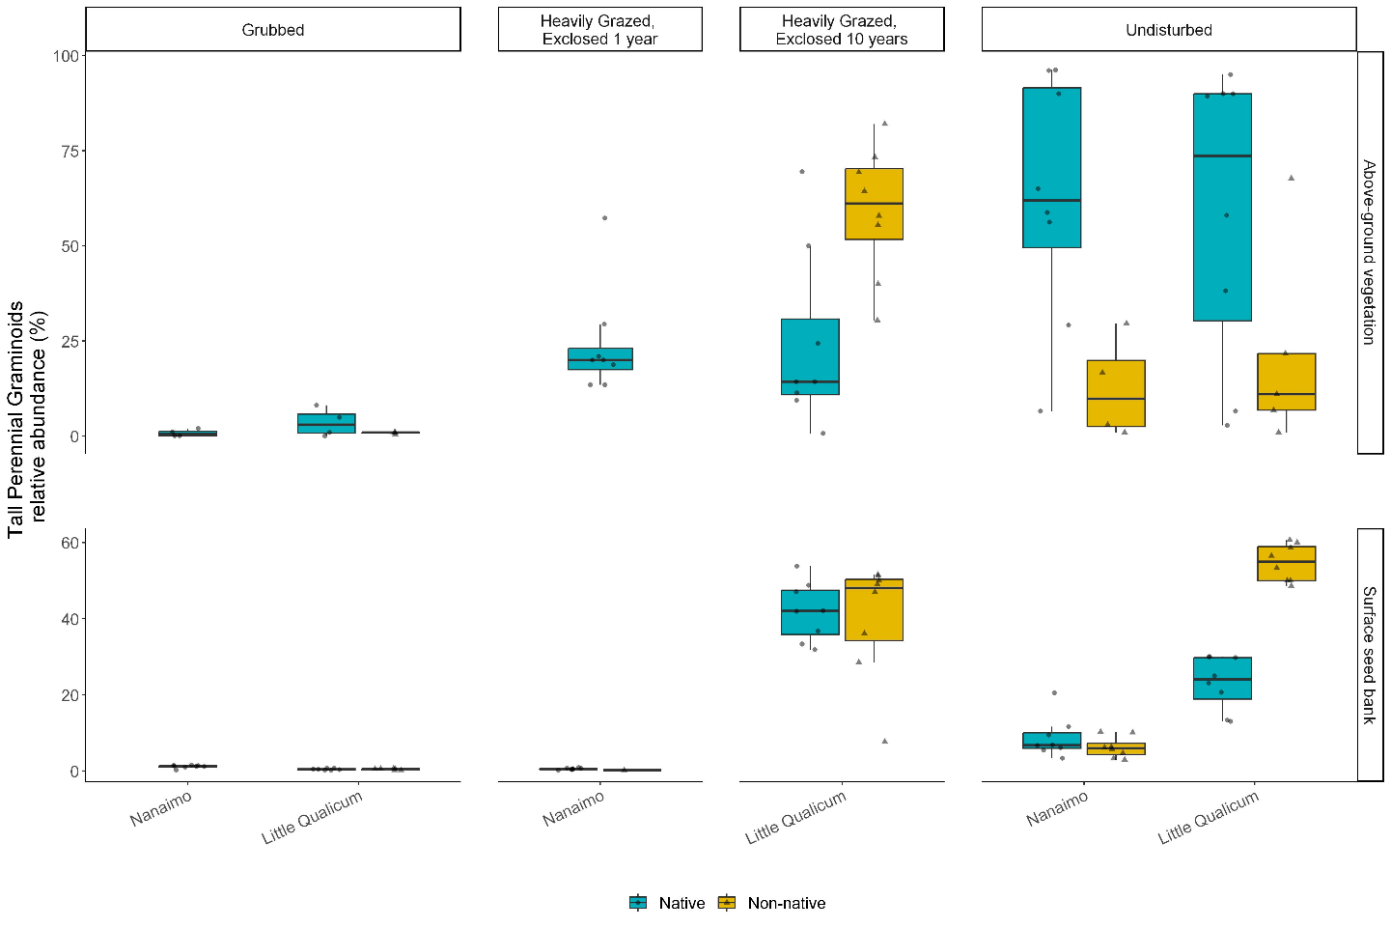

Figure 3. Above-ground cover abundance of key functional group ‘tall, perennial graminoids’ is not significantly different from undisturbed (reference) sites after 10 years. However, indicator species analysis reveals this above-ground cover is dominated by non-native graminoid species Agrostis stolonifera. Moreover, seed bank abundance of tall, perennial graminoids is significantly higher in 10-year old exclosures compared to other disturbance conditions, including undisturbed (reference) sites. Notably, there is nearly equal abundance of non-native and native graminoid seed in 10-year old exclosures, and significantly greater representation of non-native than native graminoid seed in Undisturbed sites in Little Qualicum Estuary.

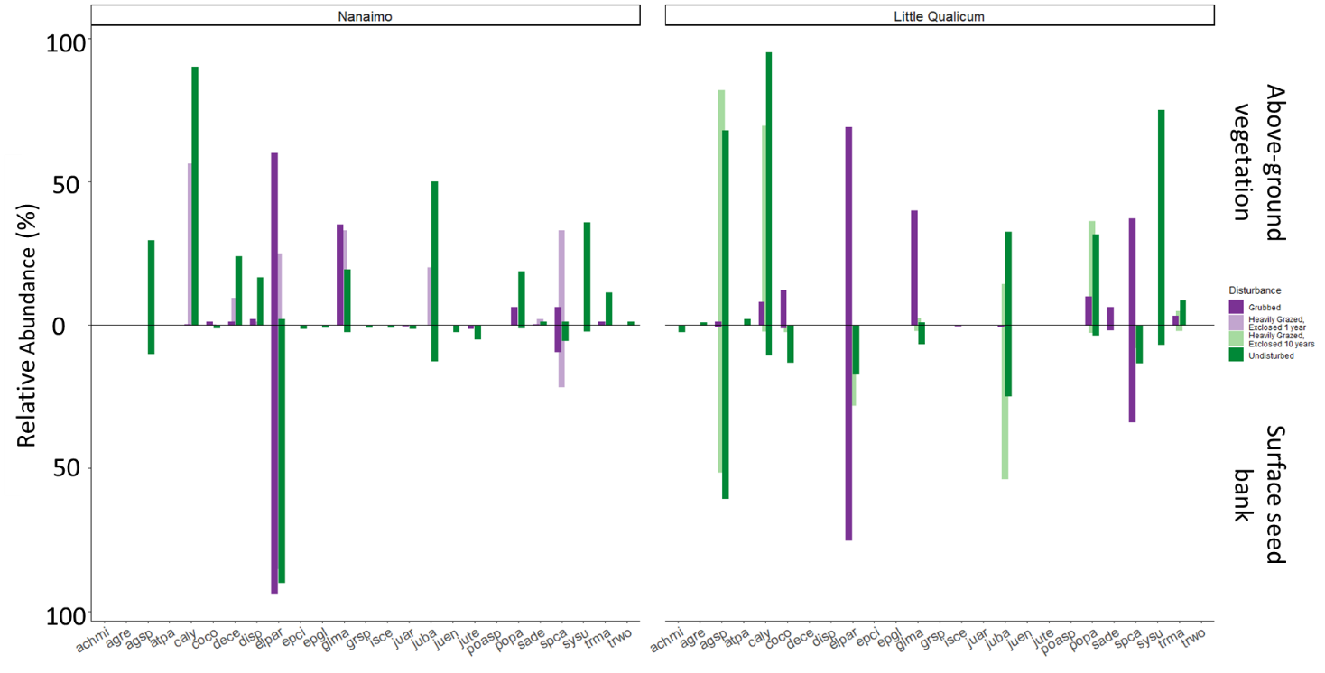

Figure 4. Mean relative abundance of all species in above-ground vegetation and surface seed bank at each estuary sampled. Notably, abundance of key native TPGs such as Carex lyngbyei are absent from the seed bank, while others such as Juncus balticus are dominant (> 25% relative abundance) in the seed bank but not dominant in above-ground vegetation, such as observed in 10-year old exclosures at Little Qualicum Estuary.

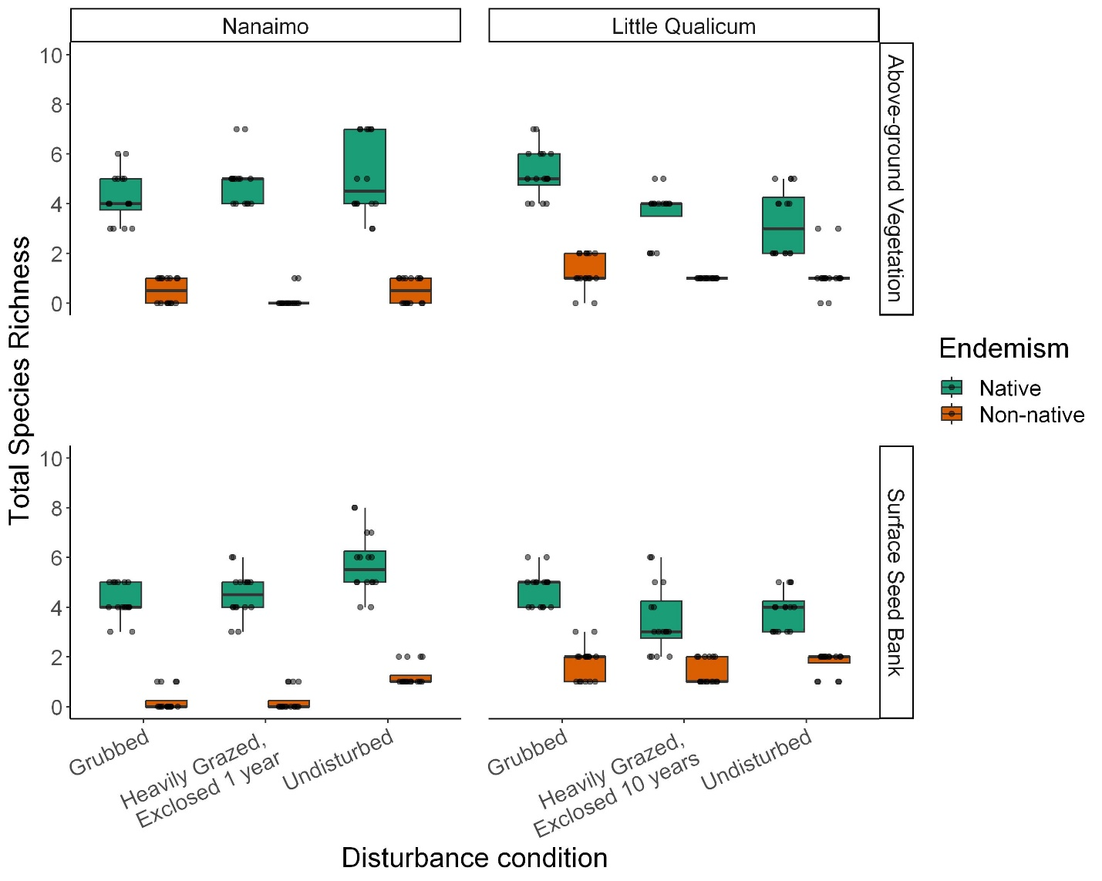

Figure 5. Species richness of native vs. non-native plants was even among disturbance categories in both Nanaimo and Little Qualicum River Estuaries for both above-ground vegetation and surface seed banks.

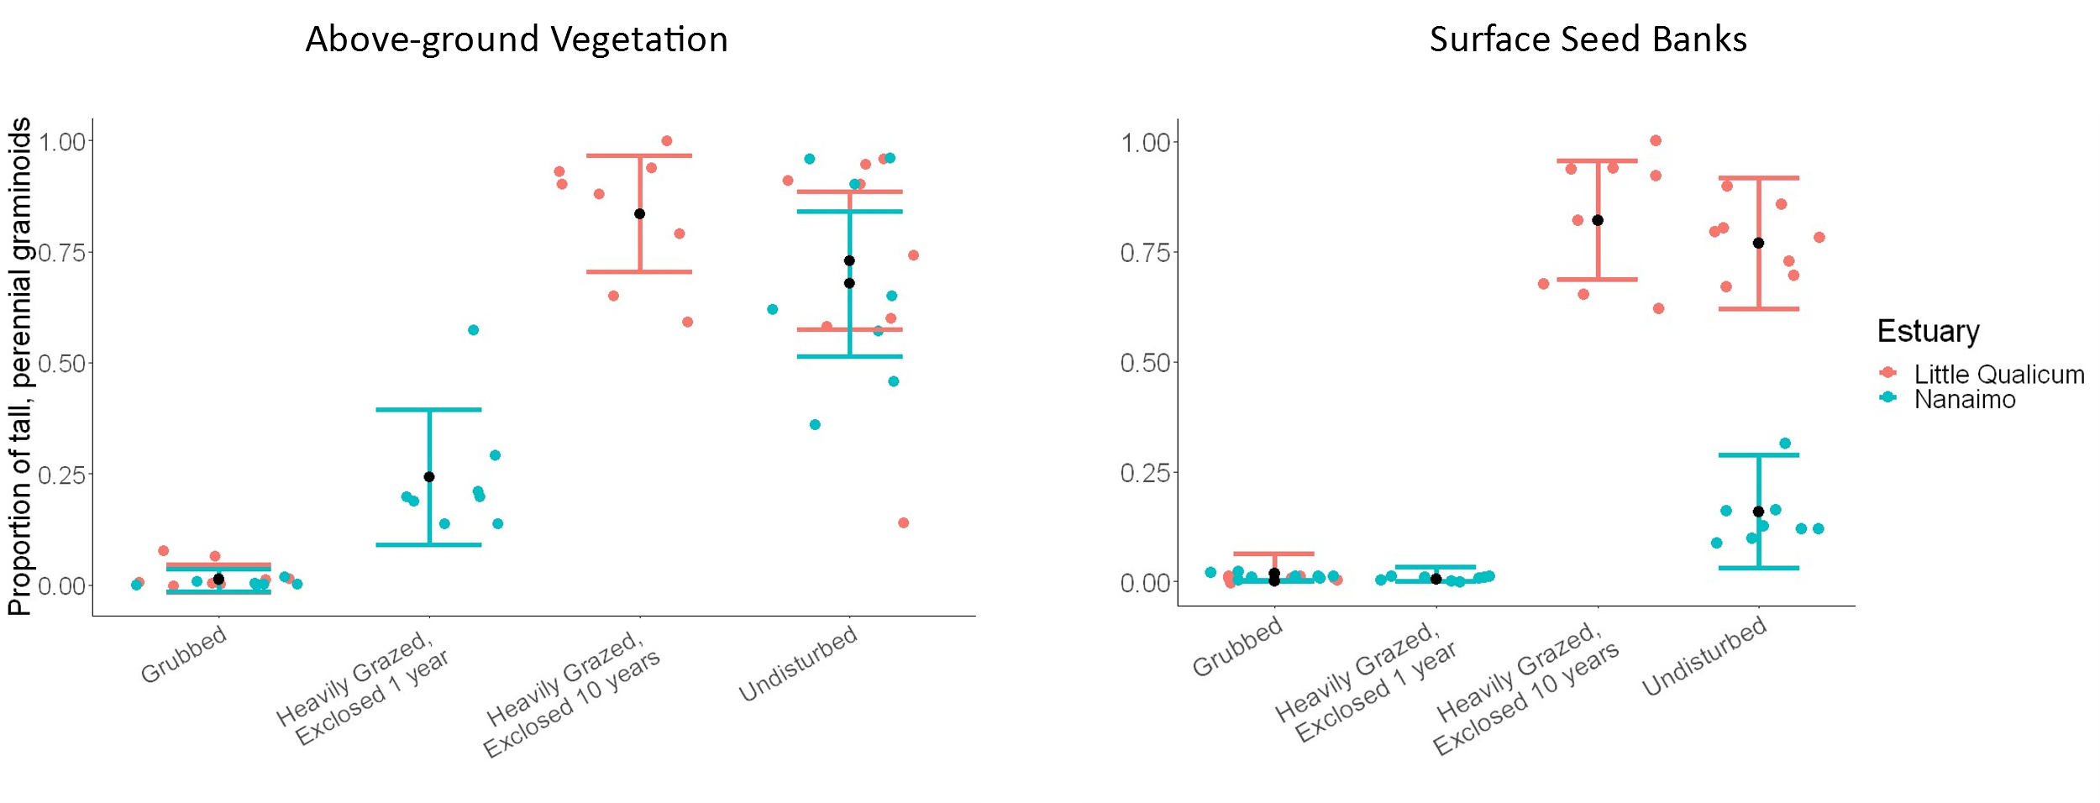

Figure 6. Actual vs. predicted values for proportion of tall, perennial graminoid in above-ground vegetation cover (left) and surface seed bank samples (right) based on disturbance condition. Actual values plotted as colored points for Little Qualicum River Estuary (salmon pink) and Nanaimo River Estuary (turquoise); estimated mean values black points with standard error color coded for each estuary.

# **Discussion**

We wanted to understand whether the competitively dominant tall, perennial graminoids (TPGs) recover following disturbance, and whether surface seed bank composition reflects above-ground vegetation composition. We found that TPGs recovered according to our expectations, however, non-native species *A. stolonifera* has invaded 10-year old exclosures, which builds support for altered succession favoring novel competitively dominant species. We found surface seed banks recovered comparable total species richness after 10 years of grazing exclusion, however surface seed banks were dominated by only two TPGs (*A. stolonifera*, *J. balticus*). Despite these two species having even seed propagule loads, native *J. balticus* is not dominant in the above-ground vegetation, suggesting that its seed and clonal reproductive strategies were not sufficient to out-compete *A. stolonifera*. It is important to note that *A. stolonifera* is not as dominant in the Nanaimo River Estuary (NRE) as in Little Qualicum River Estuary (LQRE), however it was found in the surface seed bank of Undisturbed sites at NRE. *A. stolonifera* does not appear in the surface seed banks of 1-year old exclosures at NRE, suggesting any historic seed inputs may have been lost by erosion, or they have not been deposited or retained at the recently disturbed site. We suggest this may indicate a critical window of time in which to restore native richness and abundance to prevent non-native invasion.

The two TPG species with greatest representation in surface seed banks in Undisturbed at both estuaries and 10-year old exclosures in Little Qualicum River Estuary were native *J. balticus* and non-native, invasive *A. stolonifera*. If these two species had comparable competitive traits, we might expect a similar proportion of cover abundance in the above ground vegetation in 10-year old exclosures. This was not the case, suggesting that *A. stolonifera* has a competitive advantage via recruitment of seed, clonal stems, or both during the recovery period. Competitive advantage of *A. stolonifera* may especially be contributing to lack of recovery of seed-limited native TPGs, such as *C. lyngbyei*. Some forbs like *S. subspicatum* don’t appear to recover following disturbance and may be lost from the ecological memory of the site, as seeds of this species were only found in Undisturbed seed bank samples at both estuaries.

We suggest that passive recovery through grazing exclusion alone may be insufficient to recover compositional abundance of native TPG species similar to Undisturbed areas while mitigating risk of invasive species, especially in affected areas with high propagule loads of invasive species. Seed-limited species which rely on clonal reproduction (e.g., seed-limited *C. lyngbyei*) may be at greatest risk for being out-competed if the competitor(s) have greater seed and clonal reproductive rates. We recommend transplanting a diversity of native species as soon as possible following grazing disturbance to expedite habitat recovery. We especially want to emphasize that the Little Qualicum River Estuary appears to have the greater threat of non-native invasive species encroachment, despite its status as a protected Wildlife Management Area since 1993, and reiterate calls for active management in Pacific Northwest estuaries (see also Stewart et al., 2023, Lane et al., *in review*). We propose that these management urgencies are timely in the conversation around ecological stewardship and reconciliation with First Nations, as grazing disturbance presents a “blank slate” for restoration of historic and culturally appropriate species. This offers a chance to enact reconciliation partnerships with local First Nations to use culturally important species, and potentially restore traditional land management practices such as estuary root gardens (e.g., Turner, 2014). However, we caution that restoration of cultural practices must necessarily be led and managed by each Nation (CITE), and that if time and resources cannot guarantee autonomous leadership of cultural practice by Indigenous members, we suggest prioritizing selection of culturally important species will contribute to conservation of propagule inputs within the estuary habitat.

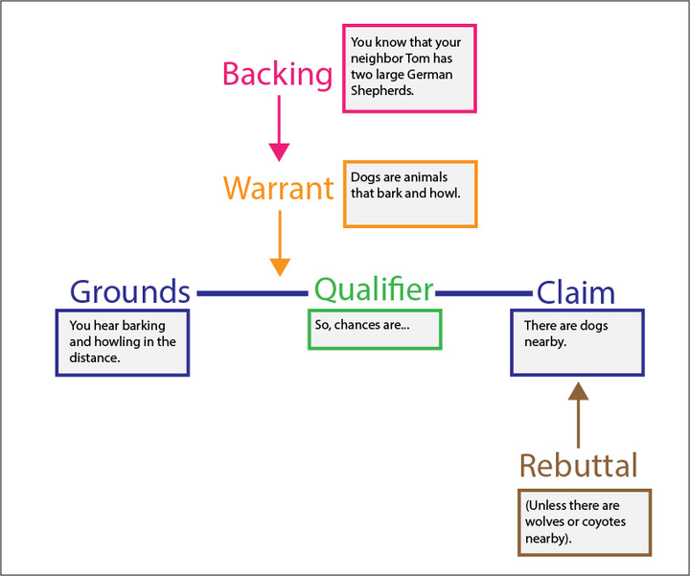

Toulmin’s argument structure

* start the paragraph with your "claim".
* Then you can bring your results that support that claim (which is the "grounds" here, the evidence that support your claim, the observations)
* And you use reference to the literature as warrant and backing to support he connection between your results and your claim

# Literature Cited

Bertness, M. D. (1991). Interspecific Interactions among High Marsh Perennials in a New England Salt Marsh. *Ecology*, *72*(1), 125–137. JSTOR. https://doi.org/10.2307/1938908

Borde, A. B., Diefenderfer, H. L., Cullinan, V. I., Zimmerman, S. A., & Thom, R. M. (2020). Ecohydrology of wetland plant communities along an estuarine to tidal river gradient. *Ecosphere*, *11*(9), e03185. https://doi.org/10.1002/ecs2.3185

Bruno, J. F. (2000). Facilitation of Cobble Beach Plant Communities Through Habitat Modification by Spartina Alterniflora. *Ecology*, *81*(5), 1179–1192. https://doi.org/10.1890/0012-9658(2000)081[1179:FOCBPC]2.0.CO;2

Choi, R. T., Petit Bon, M., Leffler, A. J., Kelsey, K. C., Welker, J. M., & Beard, K. H. (2022). Short-term effects of experimental goose grazing and warming differ in three low-Arctic coastal wetland plant communities. *Journal of Vegetation Science*, *33*(3), e13139. https://doi.org/10.1111/jvs.13139

Dawe, N., Boyd, S., Buechert, R., & Stewart, A. (2011). Recent, significant changes to the native marsh vegetation of the Little Qualicum River estuary, British Columbia; a case of too many Canada Geese (Branta canadensis)? *Journal of the British Columbia Field Ornithologists*, *21*, 11–31.

Dawe, N. K., & Stewart, A. C. (2010). The Canada Goose (Branta canadensis) on Vancouver Island, British Columbia. *British Columbia Birds*, *20*, 18.

Diefenderfer, H. L., Steyer, G. D., Harwell, M. C., LoSchiavo, A. J., Neckles, H. A., Burdick, D. M., Johnson, G. E., Buenau, K. E., Trujillo, E., Callaway, J. C., Thom, R. M., Ganju, N. K., & Twilley, R. R. (2021). Applying cumulative effects to strategically advance large-scale ecosystem restoration. *Frontiers in Ecology and the Environment*, *19*(2), 108–117. https://doi.org/10.1002/fee.2274

Douglas, G. W., Meidinger, D., & Pojar, J. (Eds.). (1998). *Illustrated flora of British Columbia. Vols. 1-8*. B.C. Min. Environ., Lands and Parks, and B.C. Min. For. https://www.cabdirect.org/cabdirect/abstract/20013088729

Finn, R. J. R., Chalifour, L., Gergel, S. E., Hinch, S. G., Scott, D. C., & Martin, T. G. (2021). Quantifying lost and inaccessible habitat for Pacific salmon in Canada’s Lower Fraser River. *Ecosphere*, *12*(7), e03646. https://doi.org/10.1002/ecs2.3646

Gonzales, E. K., & Arcese, P. (2008). HERBIVORY MORE LIMITING THAN COMPETITION ON EARLY AND ESTABLISHED NATIVE PLANTS IN AN INVADED MEADOW. *Ecology*, *89*(12), 3282–3289. https://doi.org/10.1890/08-0435.1

Hitchcock, C. L., & Cronquist, A. (2018). *Flora of the Pacific Northwest, an illustrated manual* (D. E. Giblin, B. S. Legler, P. F. Zika, & R. G. Olmstead, Eds.; 2nd ed.). University of Washington Press.

Johnstone, J. F., Allen, C. D., Franklin, J. F., Frelich, L. E., Harvey, B. J., Higuera, P. E., Mack, M. C., Meentemeyer, R. K., Metz, M. R., Perry, G. L., Schoennagel, T., & Turner, M. G. (2016). Changing disturbance regimes, ecological memory, and forest resilience. *Frontiers in Ecology and the Environment*, *14*(7), 369–378. https://doi.org/10.1002/fee.1311

Lavorel, S., & Lebreton, J. D. (1992). Evidence for lottery recruitment in Mediterranean old fields. *Journal of Vegetation Science*, *3*(1), 91–100. https://doi.org/10.2307/3236002

Lodge, K. A., & Tyler, A. C. (2020). Divergent impact of grazing on plant communities of created wetlands with varying hydrology and antecedent land use. *Wetlands Ecology and Management*, *28*(5), 797–813. https://doi.org/10.1007/s11273-020-09750-z

Megonigal, J. P., & Neubauer, S. C. (2019). *Biogeochemistry of Tidal Freshwater Wetlands*. Elsevier. https://doi.org/10.1016/B978-0-444-63893-9.00019-8

Odum, E. P. (1969). The Strategy of Ecosystem Development. *Science*, *164*(3877), 262–270.

Pasternack, G. B. (2009). Chapter 3. Hydrogeomorphology and sedimentation in tidal freshwater wetlands. In A. Barendregt, D. F. Whigham, & A. H. Baldwin (Eds.), *Tidal Freshwater Wetlands* (pp. 31–40). Backhuys Publishers.

Price, E. P. F., Spyreas, G., & Matthews, J. W. (2020). Biotic homogenization of wetland vegetation in the conterminous United States driven by Phalaris arundinacea and anthropogenic disturbance. *Landscape Ecology*, *35*(3), 779–792. https://doi.org/10.1007/s10980-020-00978-x

Schaefer, V. H. (2011). Remembering our roots: A possible connection between loss of ecological memory, alien invasions and ecological restoration. *Urban Ecosystems*, *14*(1), 35–44. https://doi.org/10.1007/s11252-010-0138-3

Silinski, A., van Belzen, J., Fransen, E., Bouma, T. J., Troch, P., Meire, P., & Temmerman, S. (2016). Quantifying critical conditions for seaward expansion of tidal marshes: A transplantation experiment. *Estuarine, Coastal and Shelf Science*, *169*, 227–237. https://doi.org/10.1016/j.ecss.2015.12.012

Stewart, D., Hood, W. G., & Martin, T. G. (2023). Undetected but Widespread: The Cryptic Invasion of Non-Native Cattail (Typha) in a Pacific Northwest Estuary. *Estuaries and Coasts*. https://doi.org/10.1007/s12237-023-01171-4

Turner, N. J., Lepofsky, D., & Deur, D. (2013). Plant Management Systems of British Columbia’s First Peoples. *BC Studies: The British Columbian Quarterly*, *179*, Article 179. https://doi.org/10.14288/bcs.v0i179.184112

Waller, L. P., Allen, W. J., Barratt, B. I. P., Condron, L. M., França, F. M., Hunt, J. E., Koele, N., Orwin, K. H., Steel, G. S., Tylianakis, J. M., Wakelin, S. A., & Dickie, I. A. (2020). Biotic interactions drive ecosystem responses to exotic plant invaders. *Science*, *368*(6494), 967–972. https://doi.org/10.1126/science.aba2225